
Department | FED
Subject | DSA-2
Academic Year | Ⅰ-Ⅲ Semester(2025-26)
Faculty Name | Ms. Alluri Swathi
Student Name | Karnati Laxmi Lahari
Roll Number | 2520090206
Branch | CSIT
Course Outcome | 1

Case Study Topic: Athlete Performance & Tournament Management System using BST
Work Done Summary:
Implemented a Binary Search Tree (BST) in Java to manage athlete performance records and tournament schedules. Athlete data was stored using performance score/ranking as the BST key. Inserted multiple athlete records into the BST and performed searching, updating, and deletion operations efficiently. Implemented ranking display using inorder traversal to show athletes in sorted order. Match schedules and tournament participant records were organized dynamically using BST operations. Compared BST performance with linear search structures and observed faster average-case searching and insertion operations.
Implementation Details :
- Created BST Node class with fields: athleteId, athleteName, score, left, right.
- insert() method adds athlete records based on performance score.
- search() method finds athlete details efficiently using BST traversal.
- delete() method removes retired/disqualified athlete records.
- inorderTraversal() displays athletes in sorted ranking order.
- Main method demonstrated athlete insertion, searching, deletion, and ranking operations
Result : Screenshots/Output
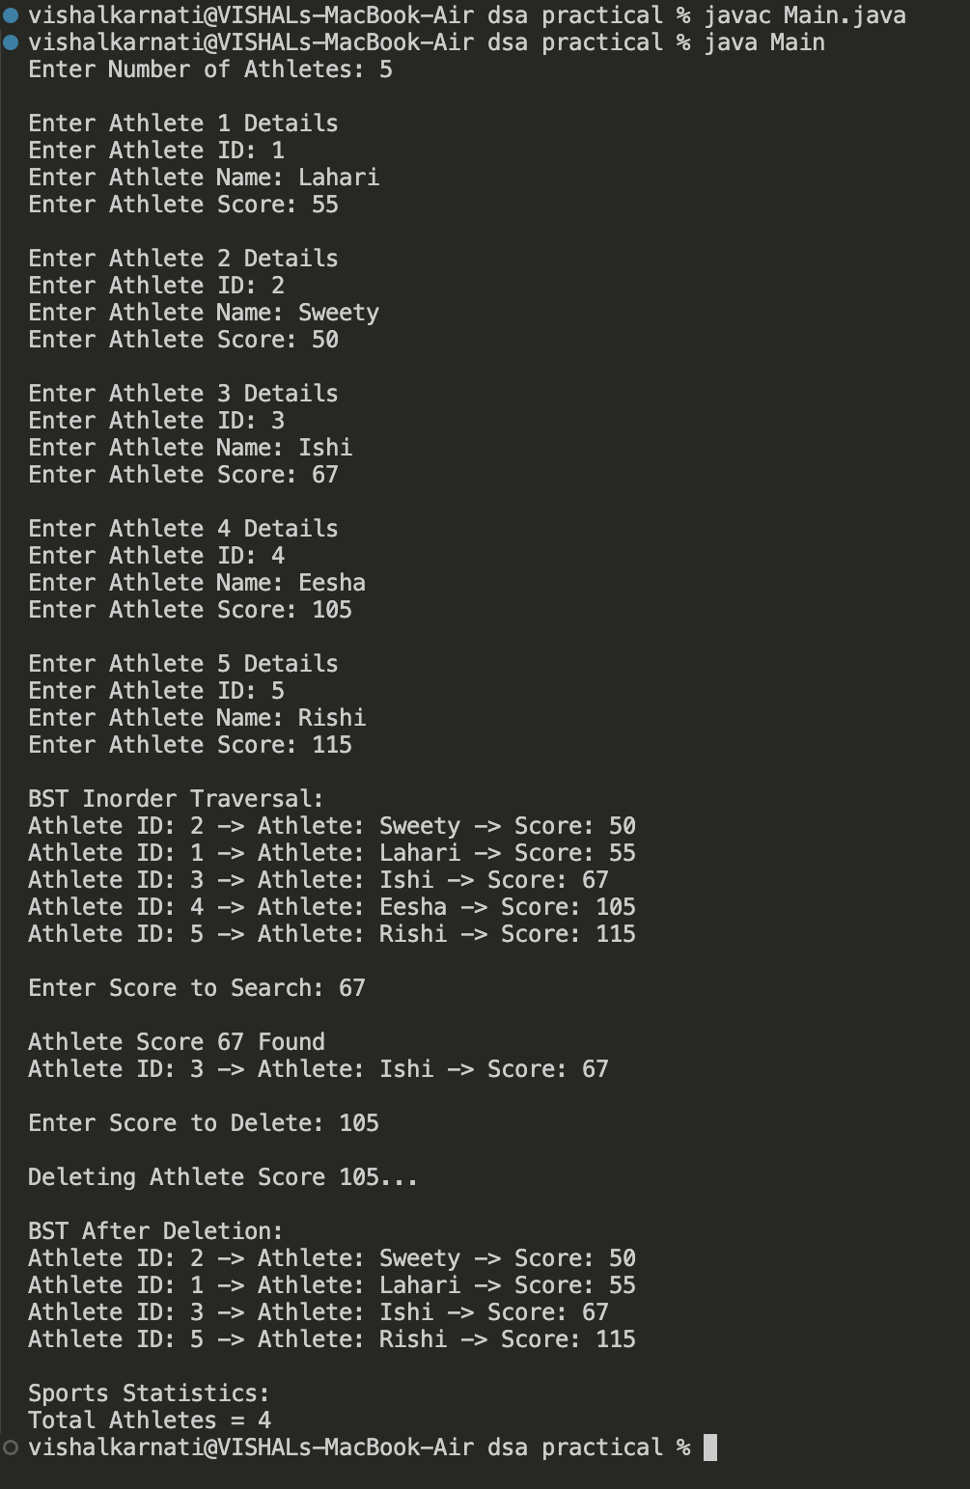Time Complexity:
- BST Insert: O(log n) average case
- BST Search: O(log n) average case
- BST Delete: O(log n) average case
- Inorder Traversal: O(n)
Compared to linear data storage methods (O(n) search), BST provides faster average-case performance for athlete management and tournament analytics.
GitHub Link :
Student Signature | Faculty Signature

